**Work in teams of 2 people.**

Use the excel spreadsheet “Workshop6.xlsx” available in comunidad. Assume you are **LONG** the IPC to answer this workshop.

**Questions to be answered in the excel spreadsheet.**

1. Construct the distribution and normal-qq-plot of a chi-squared distribution with 4 degrees of freedom. Use the chi squared left tailed function in Excel
   1. Is the left tail fatter than that of the normal distribution? (Yes=1, No=0)
   2. Is the right tail fatter than that of the normal distribution? (Yes=1, No=0)
   3. Is skewness negative? (Yes=1, No=0)
2. Filtered Historical Simulation. Use m=250 days and the GARCH variances provided to compute the following risk measures
   1. 1-day 1% VaR for October 28, 2008 using FHS
   2. 1-day 1% ES for October 28, 2008 using FHS

Note that the formula in the book for ES on page 126 has a typo. It should read:

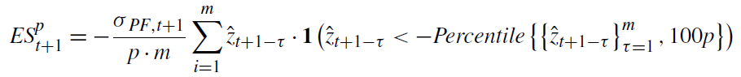

Instead of using the formula above, use the formula below to compute ES:

$${ES}_{t+1}^{p}=-σ_{PF,t+1}Average({\hat{z}}_{t+1-τ}|{\hat{z}}_{t+1-τ}<percentile\left\{{\left\{{\hat{z}}_{t+1-τ}\right\}}_{τ=1}^{m},100p\right\})$$

1. Cornish-Fisher approximation for the return series that has a skewness of -1 and an excess kurtosis of 2. Report the following measures
   1. 1-day 1% VaR for October 28, 2008 using Cornish-Fisher approximation
   2. 1-day 1% ES for October 28, 2008 using Cornish-Fisher approximation
2. Standardized *t* distribution. Find the parameter d for the return series that has a skewness of -1 and an excess kurtosis of 2. Note that the formula in the book (p.131) has typos; the right formula is:

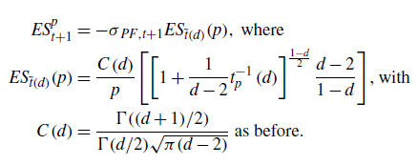

2

~

* 1. d=
  2. What is the 1-day 1% VaR for October 28, 2008 using the Standardized t-distribution
  3. What is the 1-day 1% ES for October 28, 2008 using the Standardized t-distribution

1. Asymmetric t distribution. Find the parameters d1 and d2 for the return series that has a skewness of -1 and an excess kurtosis of 2.
   1. d1=
   2. d2=
   3. What is the 1-day 1% VaR for October 28, 2008 using the asymmetric t-distribution
   4. What is the 1-day 1% ES for October 28, 2008 using the asymmetric t-distribution
2. EVT: extreme value theory.
   1. What is the 1-day 10% VaR using historical simulation and the data provided? This number will be used as the *u* needed in EVT.
   2. What is the Hill estimator equal to? Use all data provided.
   3. What is the 1-day 1% VaR for October 28, 2008 using EVT
   4. What is the 1-day 1% ES for October 28, 2008 using EVT